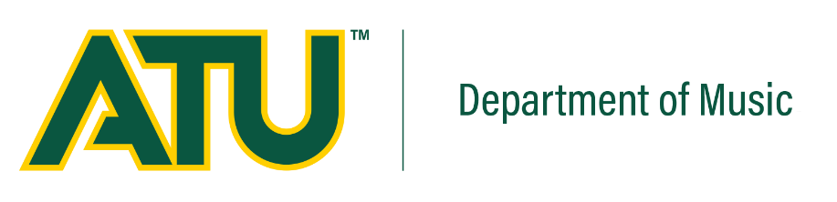

**Vocal Music Studies at ATU**:

The ATU Department of Music serves approximately 170 Music majors, seeking either the B.A in Music or the B.M.E, through which students earn public school teaching certification. Throughout the years, Tech’s Vocal Music program has achieved a tradition of excellence recognized throughout the state and region. Arkansas Tech’s choral ensembles have appeared numerous state, regional, and national conferences. Students enrolled in Vocal Music studies may participate in the Choral Artists, Concert Chorale, University Choir, the Men’s and Women’s split choral ensembles, and a number of smaller chamber ensembles.

**Arkansas Tech University Department of Music**

Dr. Jeff Bright, Department Head

Dr. Jeff Cass, Dean of the College of Arts and Humanities

For information regarding **Vocal Music Performance Scholarships**, visit our website at   
www.atu.edu/music

# 

*presents*

***ENSEMBLES***

Dr. Daniel A. Belongia, Director of Bands

Dr. Jon Clements, Choirs

Dr. Katherine Rohwer, Director of Choirs  
Dr. Sean Reed, Jazz Ensemble

***WOODWINDS***

Dr. Phoebe Robertson, Flute

Dr. Leanna Renfro, Oboe

Professor Richard Bobo, Bassoon

Dr. Nicolas del Grazia, Clarinet

Dr. Nate Mensink, Saxophone

***BRASS***

Dr. TJ Perry, Trumpet

Professor Dalton Snow, Trumpet

Professor Evan Mino, Horn

Dr. Sean Reed, Trombone & Euphonium

Dr. Ryan Matejek, Tuba

***PERCUSSION***

Dr. Cory Fica

***PIANO AND PIANO PEDAGOGY***

Dr. Tim Smith

Dr. Mary J. Trotter

***VOICE***

Dr. Barbara Clements

Dr. Jon Clements  
Dr. Amy Porter

***COMPOSITION AND MUSIC THEORY***

Dr. Jon Clements  
Dr. Nicolas del Grazia  
Dr. Nate Mensink  
Professor Evan Mino

Dr. Mary J. Trotter

Dr. Zane Gillespie  
Dr. Amy Porter

Dr. Tim Smith

***MUSICOLOGY***

Dr. Phoebe Robertson

***MUSIC EDUCATION***

Dr. Daniel A. Belongia

Dr. Jeff Bright

Dr. Katherine Rohwer

Professor Christina Head

***CONDUCTING***

Dr. Daniel A. Belongia

Dr. Katherine Rohwer

***MUSIC IN GENERAL STUDIES***

Dr. Jeff Bright

Dr. Kae Reed

Dr. Ryan Matejek

Dr. Nate Mensink

Dr. Phoebe Robertson  
Dr. Zane Gillespie  
Professor Sharon Davis

***ADMINISTRATIVE PROFESSIONALS***

Bonnie Heathcock, Band Camps Admin

Belinda Hilliard, Administrative Assistant

Dr. TJ Perry, Auditorium Management

Date, Month, Year

**Name, instrument in a (faculty/guest) recital**

assisted by:

*Performer’s Names, instrument [in lower case]*

Location and time, PM

Click in box to edit

**Program**

Click in box to edit