**VOLUNTEERS NEEDED**

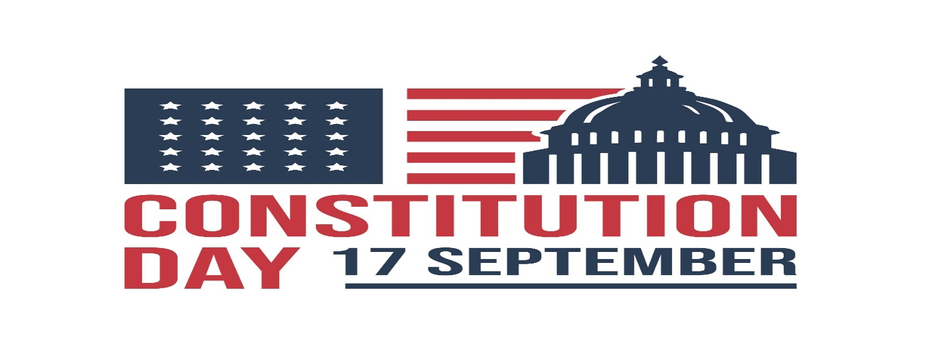

**Help celebrate the birth of the U.S. Constitution!!!**

Present educational programs to students at Russellville public schools

~or~

Participate in a public reading of the U.S. Constitution at Hindsman Bell Tower

Read U.S. Constitution * Administer Constitution Quizzes * Pass Out Free Pocket Constitutions

on

**TUESDAY**

**SEPTEMBER 17, 2024**

Contact **Dr. Jeff Pearson** or **Dr. Michael Rogers** to volunteer!

[jpearson9@atu.edu](mailto:jpearson9@atu.edu) [mrogers6@atu.edu](mailto:mrogers6@atu.edu)

or call (479) 968-0265 and leave a message

Activities Sponsored by the

**Arkansas Tech University**

**History & Political Science Department**

**College of Arts & Humanities**